Patient Participation Group Meeting
January 16th 2019 13.00pm – 14.00pm

Present: Jane Read (JR) Dr Matthew Fallon (MF), Becky Kelly (BK), Emily Marston (EM), Pam Coli (PC), Marilyn Priddey (MP), Sheila Dench (SD).

Apologies: Wendy Jenkinson (WJ), Elizabeth Hector (EH), Anne-Marie Smith (AS).

Date of Meetings for 2019:

Wednesday 17th April
Wednesday 17th July
Wednesday 16th October
Arrive 12.45pm for light refreshments, meeting 13.00pm – 14.00pm.

Agenda

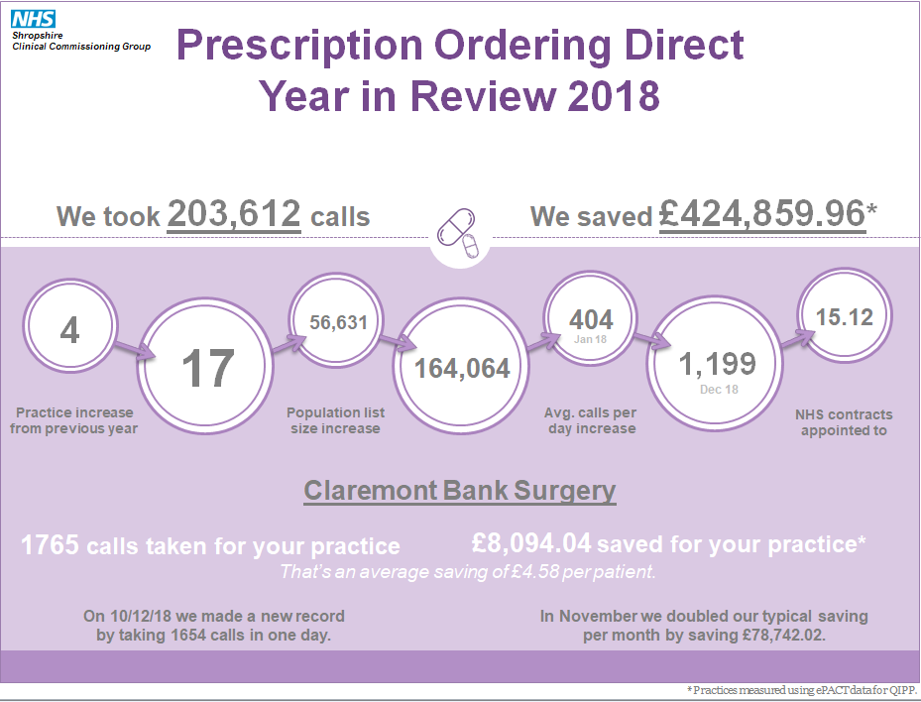
- Thanks to Stephanie Munro-Jones Prescription Ordering Direct Service Team Leader and colleague for presentation on service to date.

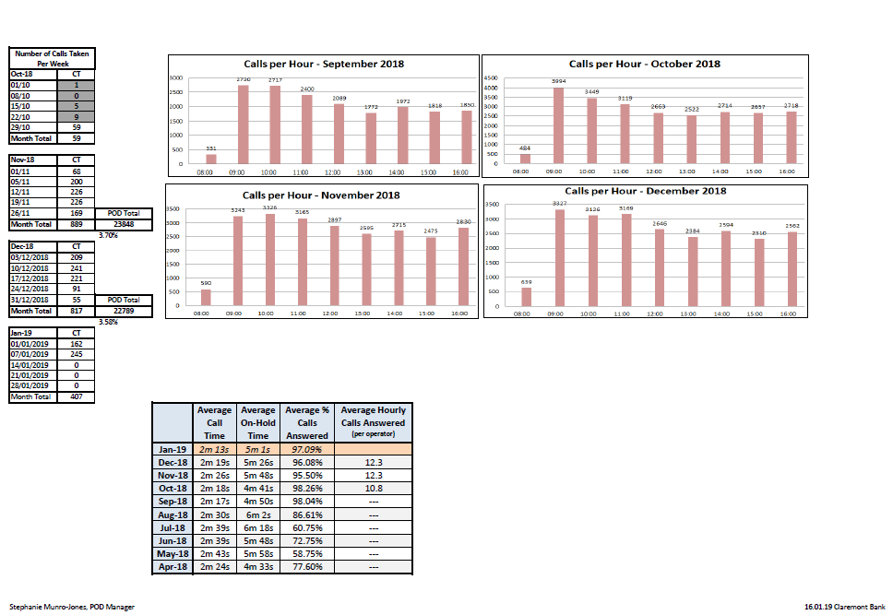

JR confirmed number of complaints has reduced as patients have got used to using the new system.
MF asked about call waiting times and how this issue was addressed.
Stephanie from POD
- No annual leave for 2 weeks in December in run up to Christmas.
- Improved staffing levels for number of practices now on board.
Confirmed Monday mornings are still the busiest but patients can only be a maximum of 25th in the queue.

Introductory message was raised as being quite long. However it’s felt that the information is relevant and helpful for patients to hear.

Confirmed POD is used by 17 out of 41 GP practices in Shropshire so far, with more coming on board during 2019. From Claremont Bank, POD receives approx. 200-250 calls per week.

PC asked how the prescription reaches the Dr’s at the surgery. MF explained POD team members have remote access to the surgery system so can access the patients medication directly and then send any requests onto the GP’s. The benefits of being able to streamline the medication for patients were also discussed. (Fewer phone calls needing to be made by patients which reduces waiting times and staffing costs, stockpiling of medications reduced, fewer requests received by GP’s so reducing workload).

Issue Raised – If prescription is requested by POD and it is rejected – how will the patient be informed? Significant event – baby milk prescription rejected and patient not told.
Action – Process needs outlining of how to inform patients.

MF would like to invite POD back for a 12 month review. EM to liaise with POD team leader for October 16th 2019, in the meantime will continue to receive quarterly updates.

Stephanie raised the potential development of a POD APP to try and capture the % of patients which are not currently using it. (Approx. half of those who could be using it).
MF – high proportion of patients are not in the demographic who are most likely to have smart phones. Online access also offers the same functionality whilst being able to book appointments as well. Also removes the ‘people’ element which provides the basis of the cost saving capabilities.

(Non-Agenda Item) Annemarie Stokes – Introduction to Social Prescribing
Thanks to Annemarie for joining us and providing an overview of her role in the surgery. Currently runs the Help2Change Clinics and carries out NHS Health Checks and recently has undertaken the role of ‘Health Coach’. Dr’s can make referrals to her for anyone who could be more suited to receiving lifestyle advice rather than medical intervention. For example, patients identified as being pre-diabetic (at risk of developing type 2 diabetes) are invited for an appointment to look at ways they could reduce that risk.

- New Security Gates
Incident with a rough sleeper has meant we have had to put up railings around all entrances to the building to ensure staff safety.

- New ST1
Dr Thi Han Zin has been with the surgery since the beginning of December. He is a Speciality Training First Year fully qualified Doctor. Speciality Training refers to the field of medical practice the Doctor has chosen to go into (in this context, General Practice).

- Our lead Nurse, Wendy Hornby, will be retiring on 30th June 2019.

- We have an admin team member due to go on maternity leave in February. Plan to recruit another apprentice to help cover the position.

- Darwin Health

- MP Online Access Issues.
Had problems with accessing her account – advised to reset the account key at reception. EM confirmed a number of problems which patients have been facing since the updates necessary since the introduction of GDPR and the need to improve security.

